**Nov 2014 SL P1**

**Section A**

1. State **one** example of application software. [1]

*Award* ***[1 mark]*** *for a valid example.*

Word processor; spreadsheet; database management system; e-mail; web browser; CAD; graphic processing software;

1. Identify **two** methods that can be used to prevent data loss. [2]

*Award* ***[1 mark]*** *for each method identified up to* ***[2 marks max]****.*

Failover systems;

Redundancy;

Removable media;

Offsite / online storage;

1. Identify **two** methods of providing user documentation. [2]

*Award* ***[1 mark]*** *for each method identified up to* ***[2 marks max]****.*

Help files;

Online support;

Printed manuals; ***[2 marks]***

1. Outline the need for higher level languages. [2]

*Award* ***[1 mark]*** *for identifying one need for a higher level language and* ***[1 mark]*** *for further development of that idea or the identification of a second need up to* ***[2 marks max]****.*

In machine language, the basic operations available are too simple;

The operations used in modern programming are far more abstract than the basic operations of the computer;

It would take too long to complete systems in machine code;

1. The contents of a 12-bit register is represented in hexadecimal as A5F.
2. State its binary representation. [1]

*Award* ***[1 mark]*** *for right binary number. Accept any spaces.*

1010 0101 1111;

1. State how many different integers can be represented in this register. [1]

*Award* ***[1 mark]*** *for either answer.*

212 or 4096;

1. Construct a logic diagram for the Boolean expression

A and B or not B. [3]

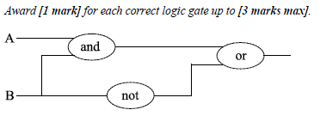

1. When the wages for company employees are calculated, all hours above 38 are paid at   
   the overtime rate of 1.5 times the base rate.

Construct a flowchart that represents this algorithm. [3]

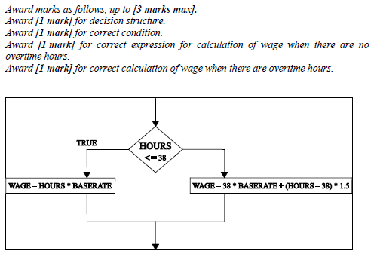

1. 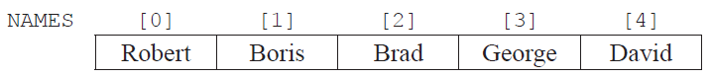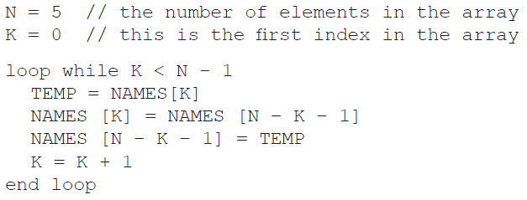Consider the following array  
     
     
     
     
   and the following algorithm, which is constructed to reverse the contents of the array NAMES.
2. Trace the algorithm, showing the contents of the array after each execution of the loop. [2]

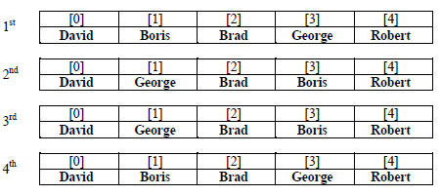

1. Identify the type of error that occurs. [1]

Logic error;

1. *Outline why the error occurs and how it could be corrected.* [2]

*Award* ***[1 mark]*** *for stating a possible cause of error.*

Loop executes too many times;

Terminating value for controlling variable was not correctly set;

*Award* ***[1 mark]*** *for stating a possible solution.*

Condition should be changed to k = n div 2;

1. (a) Outline the differences between a LAN and a VLAN. [3]

Award [1 mark] for identifying one difference between a LAN and a VLAN and [1 mark] for further development of that idea or identifying another difference up to [3 marks max].

A LAN is a physical, local area network defined by cables, and networking hardware whereas;

A VLAN is a virtual LAN defined by software parameters programmed into the networking hardware;

(b) Identify **two** factors that should be considered when selecting transmission media. [2]

*Award* ***[1 mark]*** *for each factor identified up to* ***[2 marks max]****.*

Cost;

Speed;

Security;

Reliability;

**Section B**

1. The temperature of a lake for one day is recorded every hour and data is stored in a one-dimensional array named TEMPDAY.

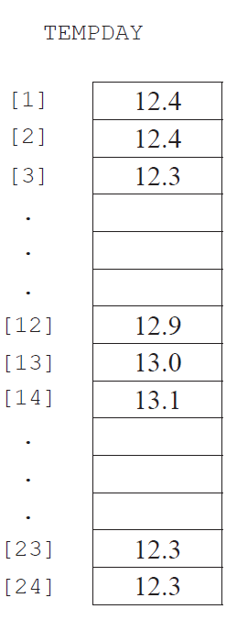

1. State the temperature of the lake at noon. [1]

12.9

1. Construct an algorithm that will calculate and output the average temperature. [4 ]

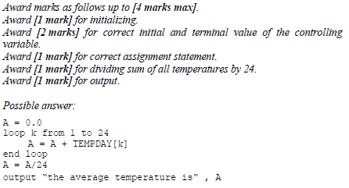

1. Construct an algorithm to find and output the minimum and maximum   
   temperatures for the day. [7]

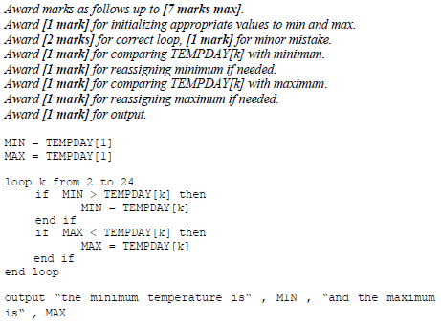

1. (i) Describe how a two-dimensional array could be used to hold temperature measured  
    every hour, every day for one week. [2]  
     
     
     
     
     
     
     
     
     
     
     
     
     
     
     
     
     
     
     
     
     
     
     
     
     
     
     
     
     
     
     
     
   (ii) Outline how the temperature on Thursday at 5pm can be accessed. [1]

*Award mark only if answer corresponds to candidate’s answer to Part (d)(i)*.

*Example answer:*

TEMPWEEK [17,2];

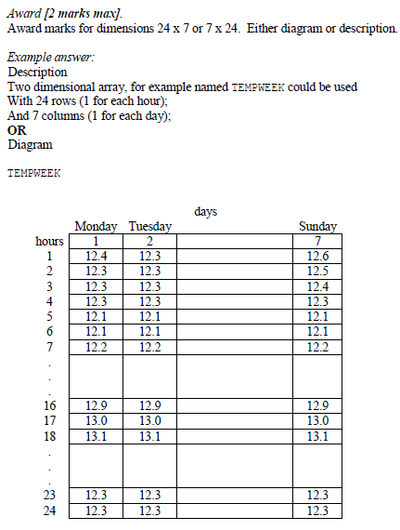

1. A business has decided to replace their current computer system with a new computer system.
2. Identify **three** examples of how employees, as users of the computer system,   
   may participate in the development of the new system. [3]

*Award* ***[1 mark]*** *for each example up to* ***[3 marks max]****.*

They may explain how the current system works;

They may explain how it could be improved;

They may provide requirements/objectives;

They may be involved in approving the proposed solution;

They may evaluate one or more prototypes;

They may test the system to ensure that it works as expected;

They will be attending the training lessons to learn how to use the new system;

They will be using the system;

1. One method of conversion from the old computer system to the new computer   
   system is parallel running.
2. Define the term parallel running. [1]

Award [1 mark] for a correct definition.

The old system continues alongside the new system for a certain period of time;

1. Identify **one** other method of conversion. [1]

*Award* ***[1 mark]*** *for one method of conversion (other than parallel running) identified.*

Direct changeover;

Phased conversion;

Pilot conversion;

1. Compare parallel running with the method of conversion identified in part (ii). [4]

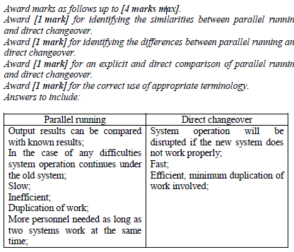

1. The data from the old computer system needs to be transferred onto the new computer system.   
   Discuss **two** problems that may arise as a result of this data migration. [6]

*Award marks as follows up to* ***[6 marks max]****.*

*Award* ***[1 mark]*** *for each distinct problem identified, up to* ***[2 marks max]****.*

*Award* ***[1 mark]*** *for a description of each identified problem, up to* ***[2 marks max]****.*

*Award* ***[1 mark]*** *for an elaboration of the identified problems.*

*Award* ***[1 mark]*** *for correct terminology used throughout.*

*Answers may include:*

Incompatible formats of data: The new system may store data in a format different from that used in the old system. This might be a simple matter of translation, such as converting integers to decimals. It could also be very difficult if the new system stores more detailed data than the old system, such as the date and time of each transaction while the old system stored only the date.

Data lost in migration: Data might be lost due to errors in the translation process or because perfect translations simply are not possible, *e.g.* if the old system stored ratings on a scale of 1–5 while the new system stored only 1–3.

The systems may be unavailable during the migration process; one way to avoid having two systems with incompatible data is to shut down the business, perform the migration, and then restart with the new system. If the migration takes a long time however, shutting down the business for that time may be undesirable.

New data may continue coming in during the migration process; if the business is not shut down during the migration process, transactions will either have to be performed on the new system without the old data being available or they will have to be performed on the old system which will add to the data needing to be migrated.

1. 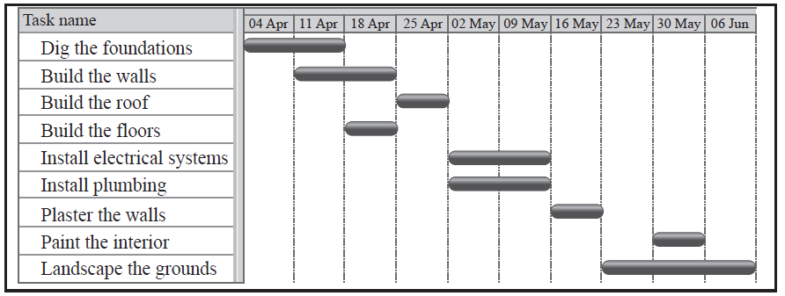Señor Rodriguez is having a new house built and will require local tradesmen to complete  
   a number of tasks.  
     
   The Gantt chart below shows the tasks involved in the building of the house.

1. Define the term concurrent processing. [1]

*Award* ***[1 mark]*** *for a definition that covers the basis of the term.*

Concurrent processing means to do more than one activity at the same time;

1. Identify **two** tasks that are carried out concurrently. [1]

*Award* ***[1 mark]*** *for a pair of tasks correctly identified.*

Install plumbing and install electrical systems

1. Identify **two** tasks that are carried out sequentially. [1]

*Award* ***[1 mark]*** *for a pair of tasks correctly identified.*

Any two tasks in which one cannot begin before the other is completed:

Digging the foundation and building the floors;

Building the walls and building the roof;

Building the roof and plastering the walls;

1. Describe how the idea of abstraction applies to one of the tasks. [2]

*Award* ***[1 mark]*** *for identifying a task as composed of subtasks.*

*Award* ***[1 mark]*** *for describing some reasonable set of subtasks.*

Describe one of the tasks as being composed of subtasks:

Build the floors: Install the beams, install the joists, install the subfloor, install the finish floor.

Paint the walls: Mask off things not to paint, cover floors, select paint colours, paint trim, paint walls, paint ceilings.

Landscaping: Plan the plantings, get the plants, dig holes, plant things, seed the lawn, install lighting.

1. Explain **one** advantage and **one** disadvantage of carrying out a number  
   of tasks concurrently. [4]

*Award* ***[1 mark] each*** *for the identification of an advantage and a disadvantage.*

*Award up to* ***[2 marks]*** *for explaining the advantage and disadvantage.*

*Advantages:*

Building could be finished faster; By doing some tasks concurrently, the overall time needed to complete the building will be reduced. Since construction workers are paid by the hour, getting the building done sooner will reduce the cost of the building.

*Disadvantages:*

Workers on concurrent tasks may get in each other’s way; If the plumbers and the electricians are both working at the same time and both need to get at the same place at the same time, one will have to wait. Thus, it may take longer to do the electrical work while the plumbing is being done than it would take to do it alone.

Harder to supervise; The supervisor needs to look at the work being done and make sure that its being done correctly and explain what needs to be done, *etc*. If there are two (or more) sets of workers the supervisor will have to work harder to watch both of them at the same time.

Amalia Rodriguez, his daughter, is a student and is completing her homework.   
 This requires her to view web pages, edit a document, and print out draft copies.

However, she is also surfing the web, keeping up to date on her social networking  
 site as well as downloading apps and music from a P2P site.

1. For one of the application programs which she uses to perform these activities,  
   outline one task that is carried out by the application program itself. [2]

*Award* ***[1 mark]*** *for identifying an application.*

*Award an additional* ***[1 mark]*** *for outlining a task carried out by the application.*

The word processor: counting the number of words in the document.

The browser: Interpreting the HTML to figure out what to display.

The downloading program: Calculating the amount of time remaining to complete the download.

Within the application the graphical user interface (GUI) elements are reliant on the   
 operating system.

1. Identify two GUI components that are common to all of the above and are carried  
   out by the operating system. [2]

*Award* ***[1 mark]*** *for each GUI component identified up to* ***[2 marks max]****.*

Toolbars;

Menus;

Dialogue boxes;

Buttons;

Check boxes;

Text-entry fields;

1. Outline how the use of abstract GUI components simplifies application programming. [2]

*Award* ***[1 mark]*** *for identifying one way in which the use of abstract GUI components simplifies application programming.*

*Award an additional* ***[1 mark]*** *for a description of the idea identified above or the identification of a second idea up to* ***[2 marks max]****.*

Application developers do not have to implement basic GUI components.

All applications use the same basic GUI elements resulting in a better user experience.

The operating system coordinates GUI elements for all applications reducing the need for developers to do so.

Application code is much smaller since all the GUI-related code is in a standard library.